Task 1
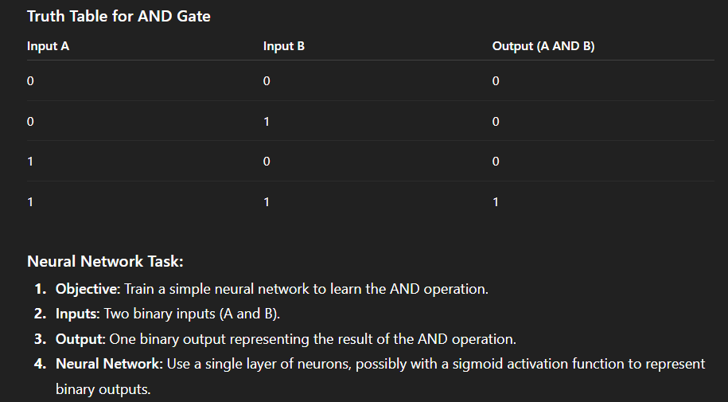

Task 2

https://www.kaggle.com/datasets/shriyashjagtap/heart-attack-risk-assessment-dataset

